Set 13 – Geographic Data Analysis
Dataset: Geographic Data
Question 1: Create a map chart to visualize the distribution of cities on a geographic map. Label the map elements.
Answer
A map chart places each city at its location, with bubble size showing population and colour showing average temperature.
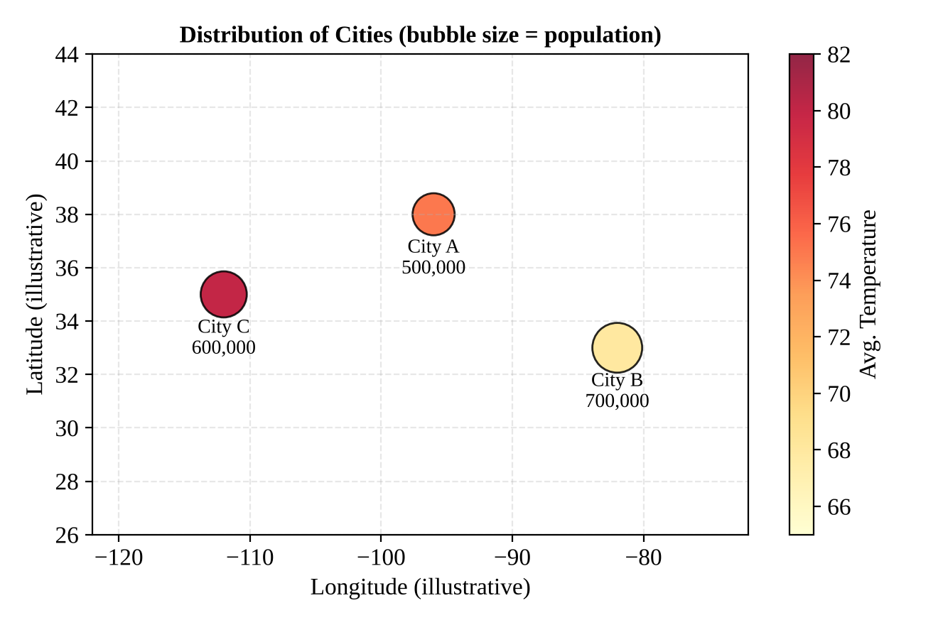
Figure 1: Bubble map of cities (size = population, colour = temperature)
Note: The dataset gives only city names (City A, B, C) and no latitude/longitude, so the positions above are illustrative placeholders. In Tableau, generic names such as “City A” are not recognised, so you must supply real coordinates (or real city names).
Map elements
- Title: Distribution of Cities
- Bubble size: Population (City B is the largest at 700,000).
- Colour: Average Temperature (City C is the warmest at 80, City B the coolest at 68).
- Labels: City name and population.
Tableau steps
- Add Latitude and Longitude fields for each city (or assign locations via Edit Locations); drag them to Columns/Rows → Map; put Population on Size and Avg. Temperature on Color; City on Label.

Set 13 – Geographic Data Analysis
Dataset: Geographic Data
Question 2: Generate a scatter plot to explore the relationship between average temperature and population size. Explain any insights.
Answer
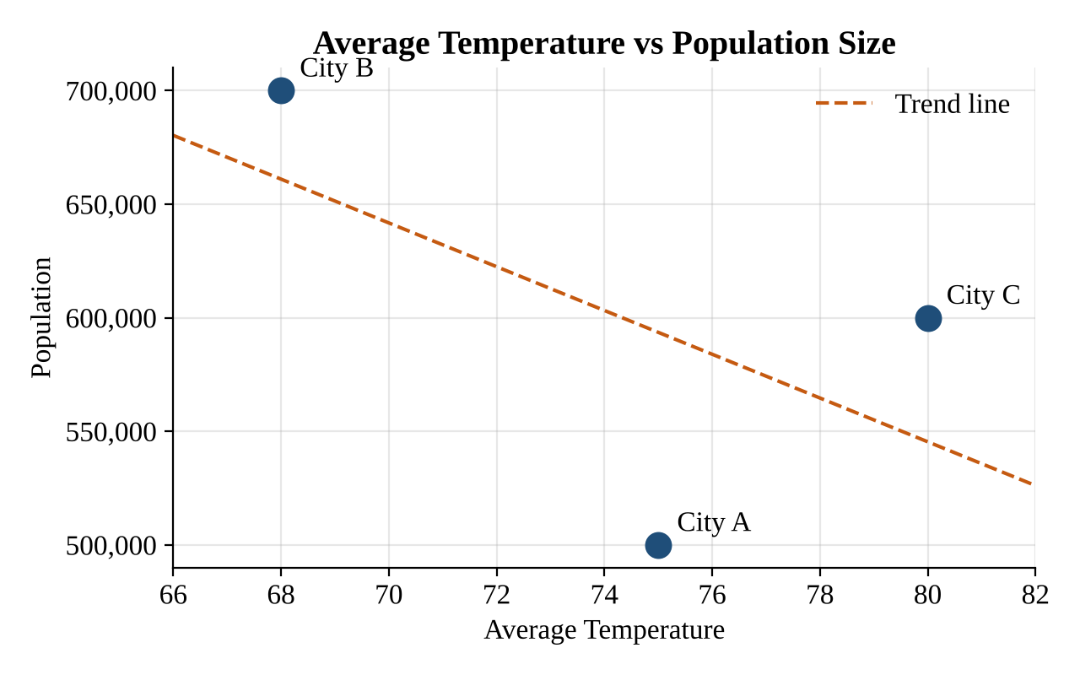
Figure 2: Scatter plot of average temperature against population
Insights
- Direction: The trend line slopes downward – the cooler city (City B, 68) has the largest population (700,000), while warmer cities have smaller populations (City A: 75 → 500,000; City C: 80 → 600,000).
- Strength: The correlation coefficient is about r = −0.58, a moderate negative relationship.
- Caution: City A and City C do not follow a clean pattern (the warmer City C is larger than City A), and with only three data points this cannot be treated as evidence that temperature affects population. More cities are needed for a reliable conclusion.
Tableau steps
- Drag Avg. Temperature to Columns and Population to Rows (as Dimensions/disaggregated), put City on Label; Analytics pane → Trend Line.

Set 13 – Geographic Data Analysis
Dataset: Geographic Data
Question 3: Build a table to display the geographic data for each city. Label the table elements.
Answer
The table below lists the geographic data of each city, with every column labelled.
City | Population | Avg. Temperature | Elevation
City A | 500,000 | 75 | 1,000
City B | 700,000 | 68 | 800
City C | 600,000 | 80 | 1,200
Table 1: Geographic data by city
Table elements
- City – name of the city.
- Population – number of residents.
- Avg. Temperature – average temperature of the city (units as given in the dataset).
- Elevation – height of the city above sea level (units as given in the dataset).
Summary statistics
Measure | Population | Avg. Temperature | Elevation
Minimum | 500,000 | 68 | 800
Maximum | 700,000 | 80 | 1,200
Average | 600,000 | 74.3 | 1,000

Tableau steps
- Drag City to Rows and use Measure Names / Measure Values for the other fields → Show Me → Text Table.

Set 13 – Geographic Data Analysis
Dataset: Geographic Data
Question 4: Develop a Tableau dashboard combining the map chart, scatter plot, and the table for interactive exploration of geographic data.
Answer – Dashboard layout
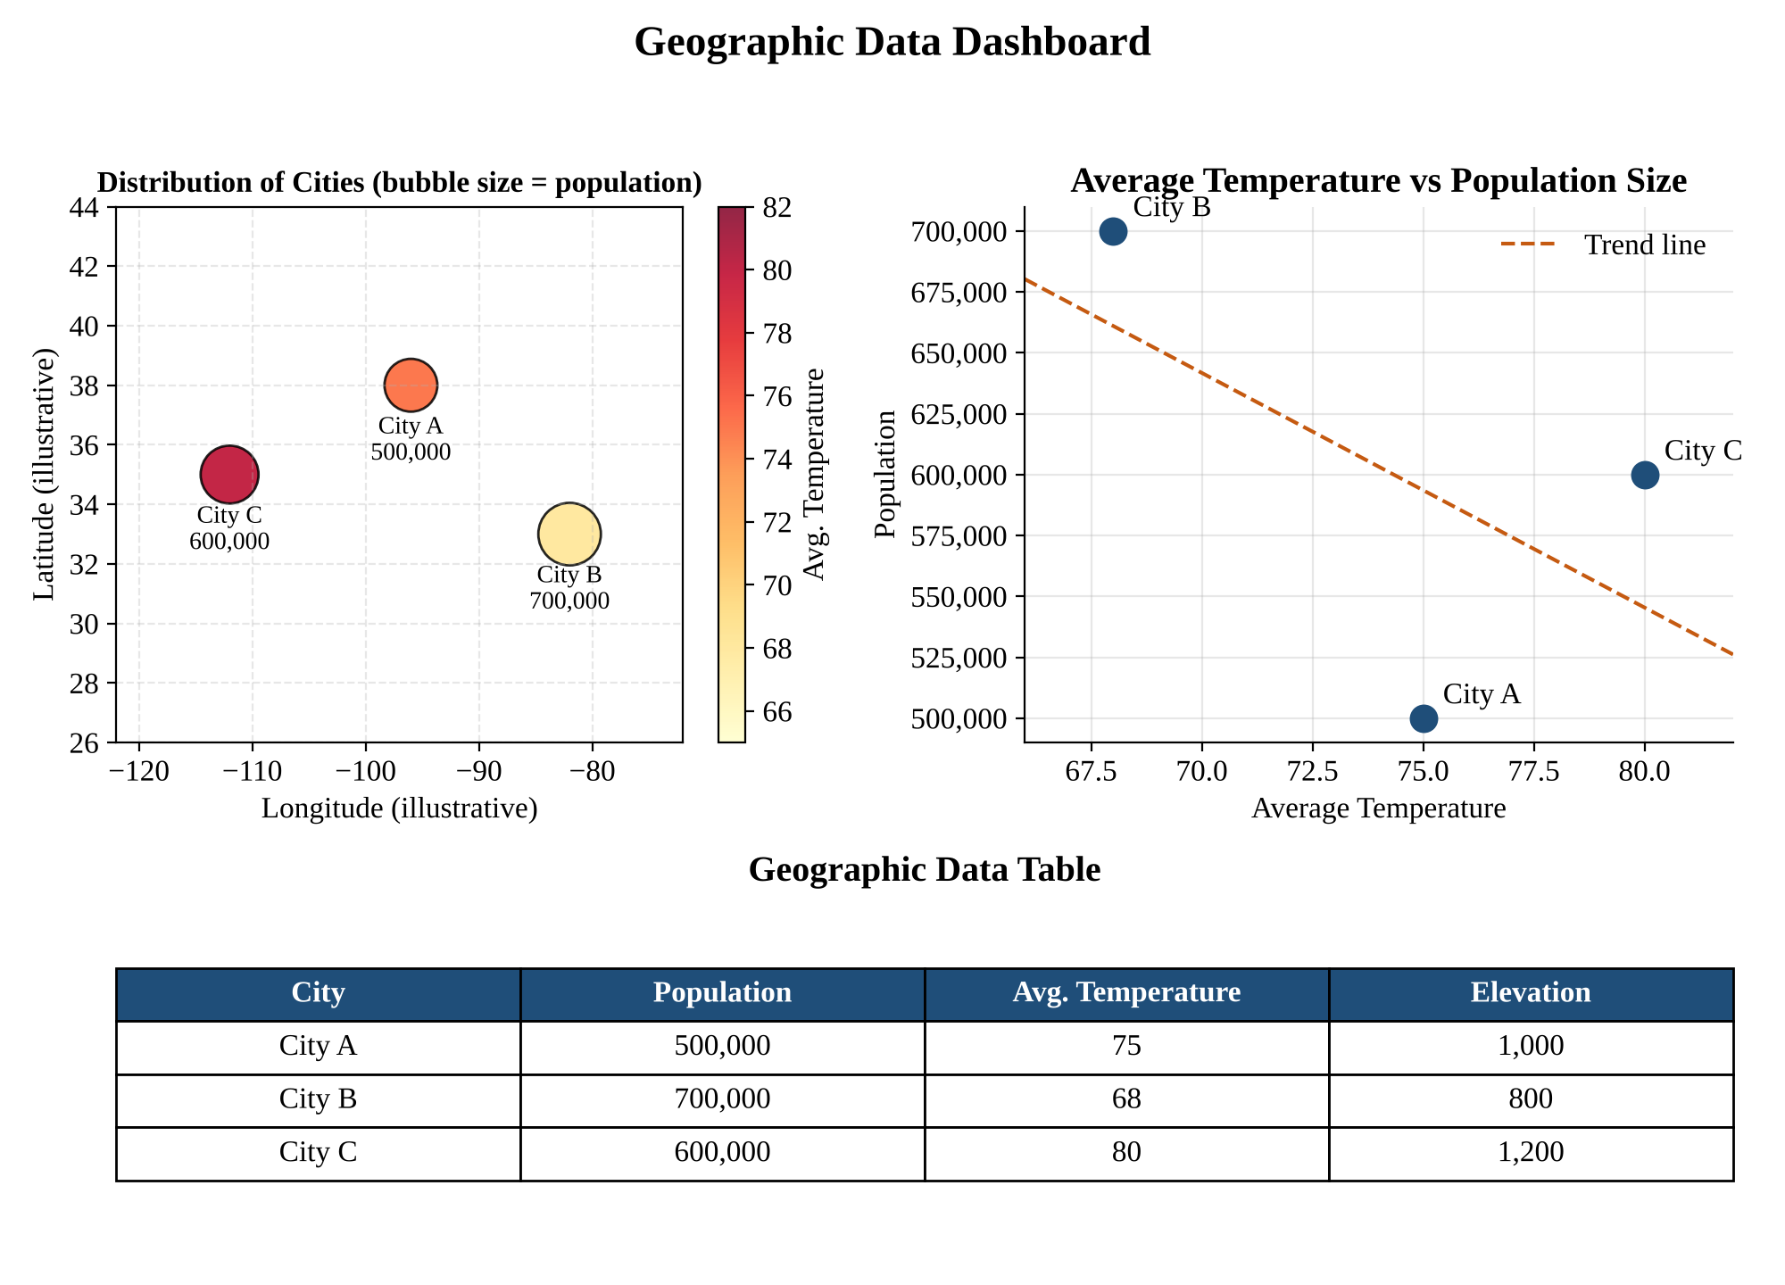
Figure 3: Geographic Data dashboard (map, scatter plot and table combined)
Steps to build it in Tableau
Step 1. Create three worksheets: City Map, Temperature vs Population and City Table (Questions 1–3).
Step 2. Click New Dashboard; set Size to Automatic or Fixed (1000 × 800).
Step 3. Place the map and scatter plot in the top row and the table in the bottom row.
Step 4. Enable ‘Use as Filter’ on the map and scatter plot so selecting a city filters the other views and the table.
Step 5. Add filters for Population and Elevation (applied to all worksheets) and a dashboard title.
Step 6. Save/publish the workbook (Tableau Public or Server).

